asHiking/general outdoor activities kit list

Day hiking
What | Picture | Why? | Cost (with Scout discount at Cotswolds)
Rucksack | 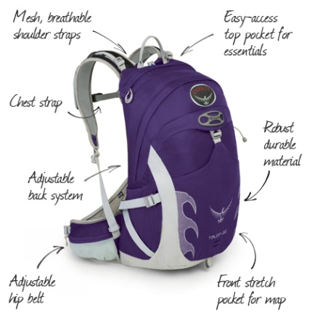 | - To carry your kit! You’ll need a bag that has 20-40 litres of capacity (more for the winter because you’ll need extra layers of warm clothes).  - Getting a good bag is important because having a comfortable fit with good back support and a hip belt means that you will be able to carry your kit comfortably and not get a sore back while walking.  - Having a proper walking bag gives you features that make it easier to access your kit, | £18+
Emergency bivouac bag | 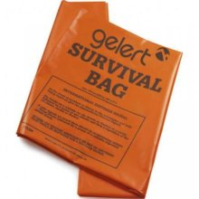 | - To keep you dry and warm in an emergency – this is absolutely essential to keep in the bottom of your rucksack and should always be carried with you | £3.50
Waterproof jacket | 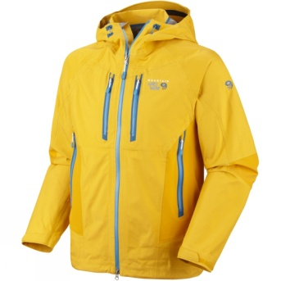 | - To keep you dry and warm by keeping out wind and rain - this is important to stop you getting hypothermia!  - It is important to get a breathable jacket as if you don’t you’ll get sweaty and damp clothes anyway! Generally, the more expensive the jacket, the lighter, more waterproof and more breathable it is! | £40-£150+
Waterproof trousers |  | - As with waterproof jackets, it is important to keep your bottom half dry too!  - As you’re less likely to wear these, it’s probably ok to get less breathable/cheaper options, but they are still important if it gets really wet! | £10+
Torch with spare battery | 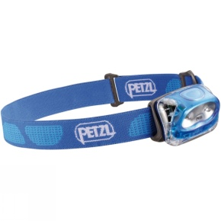 | - In case it gets dark – so you can find your way! They are also a useful safety tool to attract help.  - Head torches are best as then you can read a map and use a compass etc!  - Worth noting: quality brands (i.e. Petzl) often come with better guarantees that they will last and can be worth the investment. | £8.50+
Walking boots | 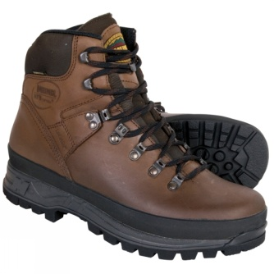 | - To keep your feet dry, give you good grip and decent ankle support  - Visit a good outdoor shop to find a pair of boots that fit well and suit you!  - Don’t spend hundreds of pounds if your feet are still growing! | £50 (if you find a good boot on sale) - £170
Gaiters | 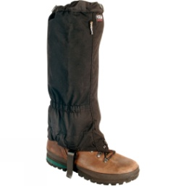 | - If walking through particularly muddy or wet conditions, gaiters keep your boots dry by stopping water that might go over the top of them  - These aren’t necessary as we won’t often do that, but they are great if you’re walking through marshland or a bog! | £12-25
Water bottle | 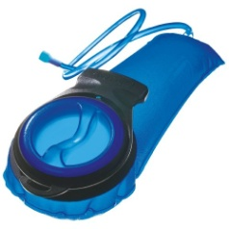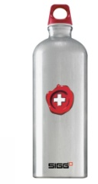 | - Keeping hydrated while walking is important as you sweat more than you think!  - A litre water bottle is essential (but reusing a fizzy drink bottle can be ok if you take two!)  - Some people like the “CamelBack” water reservoirs which keep the water against your back and you can drink through a tube while walking without having to stop! | £FREE – £25 (CamelBack)
Thermos flask |  | - Especially on a cold day, having a warm drink to have when eating lunch is a nice thing to have! | £5
Whistle | 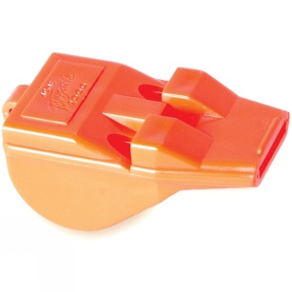 | - Essential to attract attention in an emergency situation – this should always be in your back (along with a survival bag) | £2-4
Hat & Gloves | 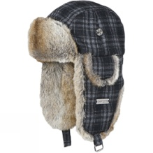 | - To keep you warm and looking cool! | £5
Warm clothes | 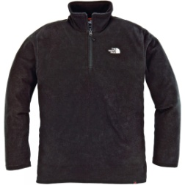 | - Multiple layers of clothing are important to keep you warm and let you control your temperature.  - You also need spares when you’re walking in case you get cold!  - Speak to an outdoor shop for advice on what to get but generally things like fleeces are great to keep you warm and they will explain the different clothing that works particularly well as base layers etc.  - Don’t wear heavy material that absorbs water like jeans – water cools you down much faster than cold clothes so increases risk of hypothermia. | £5 - £50
Personal first aid kit | 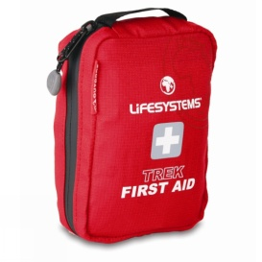 | - We always carry group first aid kits, but it’s good to have one of your own, just in case. | £10

Overnight trips/camping

What | Picture | Why? | Cost
Sleeping bag |  | - You need something to sleep in and keep you warm.  - Prices vary massively between different types of bags and different seasons and material type – avoid buying a down bag as if it gets wet it stops keeping you warm  - Remember if you’re doing an overnight hike (e.g. DofE) you have to carry your sleeping bag so weight is important | £35 - £400+ (you definitely don’t need the most expensive ones!)
Insulating mat | 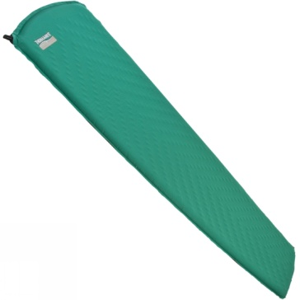 | - The ground is cold and can cause you to get cold at night - an insulating mat keeps you warmer and is a worthwhile investment  - Thermarest-like products which are small and inflatable are good because they are better padding and offer even more insulation | £5 - £50
Spoon, knife, fork, mug, bowl/plate |  | - You need something to eat with, eat from and drink from  - In a super-lightweight hike, you could survive with just a spoon and giant mug, but getting a SPORK and a MESS TIN is probably a good idea – you can even cook your dinner in the mess tin! | Around £5 each

